Purpose Section:
The purpose of this document is to provide a framework for the development team of FreshTime to ensure quality software across all components and services being provided.
Quality Plan (as suggested by Humphrey, pg 653 of textbook) Section:
1) Product Introduction: This product is a restaurant-vehicle-destination system that will optimize deliveries by minimizing average time-to-delivery. The intended market is the Delivery Service “FreshFood”. The quality expectations of this product include: ensuring that all deliveries are made while the food is still “fresh”, handling up to 1,000 food orders every hour, supporting at least 25 restaurants to receive orders from, and being able to accurately calculate and display the average time-to-delivery.
2) Product Plans: Critical release dates include the finalization of our GUI by 5/9/2022 and then the completion of our time-to-delivery calculation algorithm by 5/16/2022. Responsibilities for the product include a clear line of communication with our clients from FreshFood to indicate our progress and time to completion of their requested product. We also want to present FreshFood with current iterations of the algorithm and GUI to gather feedback and guarantee customer satisfaction.
3) Process Descriptions: 4 Processes that we will follow throughout product development include listening to feedback, gathering ideas, prototyping, and finally manufacturing of the final product.
4) Quality Goals: For our software to meet quality requirements it must be both robust and reliable. To be considered Robust, our product must continue to function even given incorrect, insufficient, or overabundant inputs. In our specific case, this means that our data parser should be able to confirm that our given inputs for latitude and longitude are formatted correctly, it should be able to handle the maximum number of orders per hour (1,000), it should also be able to correctly handle inputs of 0 orders, and it should be able to notify the user of any inputs they must present for our software to reliably calculate the average time-to-delivery. To be considered Reliable, our product must be able to consistently perform the average time-to-delivery calculation AND ensure that all deliveries are made while the food is still “fresh” given an expected set of inputs.
5) Risks and Risk Management: Key risks that might affect product quality include the inputting of latitude and longitude coordinates for restaurant and delivery locations that cannot be reached by a driver within the food’s “fresh” time. The way this risk can be managed would either be by notifying users who make orders from these restaurants that are “out of range” that their food will not be “fresh” and/or disallowing deliveries that are too far away (potentially having a max time-to-delivery of 1.5x or 2x “fresh” time).

Review Section:
Diagram Defining General Review Process: 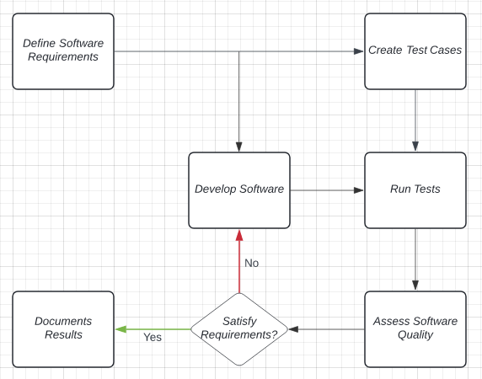
**When documenting results, ensure that the steps required throughout the process are also recorded. This should include every time that the software fails the quality assessment (does not satisfy requirements and must reenter development)**
Review Process Application for GUI (Planned for the week of 5/2/2022 - 5/9/2022:
Software requirements: Ensure the GUI accepts the correct inputs, displays detailed error messages given incorrect inputs, is easy to read/understand, and is able to perform the proper functionality within the program.
Create Test Cases: Layout a list of all screens and the controls on those screens. Systematically attempt valid and invalid inputs and cover all potential GUI states.
Assess Software Quality: If the GUI properly handles valid inputs by displaying correct outputs and displays correct error messages given invalid inputs or failures, then the software correctly satisfies its requirements.
Review Process Application for Delivery Time Algorithm (Planned for the week of 5/9/2022 - 5/16/2022:
Software requirements: Ensure delivery time is as low as possible (fast enough delivery that the food is still “fresh”), also make sure that the software is capable of handling up to 1,000 food orders and can pull orders from at least 25 restaurants at a time. Also calculate average time-to-delivery based on the inputted number of drivers.
Create Test Cases: Input 25 restaurant locations, 1,000 food orders, define a maximum delivery time for the food to still be considered “fresh”, and progressively test with an increasing number of drivers (increment starting from 0).
Assess Software Quality: If all orders are able to be delivered within “fresh” time and the calculated time-to-delivery is minimized given the current number of drivers, then the software correctly satisfies its requirements.
Inspection Section: Design inspection is done using a checklist that inspects the below areas of software design:
    - General requirements and design
    - Functional and Interface specifications
    - Requirement traceability
    - Logic
    - Performance
    - Error handling and recovery
    - Testability, extensibility
Functional Testing: Functional testing is performed using the following sequence of events:
- We made a spreadsheet comparing metrics against popular applications. (We used google maps to compare to ORSfactory)
- We made tests using an automated testing framework. (Junit tests)
- Problem reporting and corrective action section
- Tools, technologies and methodologies section
- Code control section
- Records: Collection, maintenance and retention section
- Testing methodology

